Chapter 4
Data Communication and Networking Concepts

- What is a Network?
In the computer world, the term network describes two or more connected computers that can share resources such as data, a printer, an Internet connection, applications, or a combination of these.
The computers on a network may be linked through cables, telephone lines, radio waves, satellites, or infrared light beams.

Basic components of a Computer Network
Every computer network environment consists of the following five basic and indispensable components:
- Shared data: refers to the data (software) that are shared among the computers on the network. E.g.: files, programs like Ms Word, Access…
- Shared peripheral: refers to the peripheral devices (hardware) shared among the computers. E.g.: printer, modem…
- Media: refers to the cables (wires) used to connect the computers and hence enable them to communicate.
- Client: refers to the computers which take (get) resources needed from other computers (servers).
- Server: refers to the computers which provide the resources needed to other computers (clients) on the network.

- Advantages and Disadvantages of Networking
Advantages of Networking
a) Sharing of peripheral devices:
- Laser Printers, Hard disk drives and Scanners are examples of peripheral devices. All these devices cannot be connected to each and every computer as they are very expensive. Hence, these devices can be shared by many users through a network.
b) Sharing of Programs and data:
- In many organizations, people use almost the same software and access the same data. If these software and data were made available for individual users separately, then it is wastage of memory. Hence, by sharing the software and data the usage of memory can be minimized, thereby minimizing the expense.
c) Better Communication:
- In the digital world, information can be transferred within fraction of a second over long distances. And one of the greatest features of networks is Electronic Mail (E-Mail) system. Thus, a company can eliminate the delays encountered with standard postal services or with telephone tag, by using E-Mail services.
d) Security of information:
- Before networks became a common place, an individual employee was storing information in his or her desktop computer which was not secured. But today, such data or information could be backed-up or duplicated on a network storage device, shared by others.
Disadvantages of Networking
  - Computer viruses can easily be shared affecting badly the network performance and the performance of the computers.
  - Difficult to secure information. Confidential documents (files) can be accessed without the knowledge and permission of the owner.

- Types of Networks

Based on the size, the Networks are classified into three types:
- Local Area Networks (LAN)
- Metropolitan Area Network (MAN)
- Wide Area Network (WAN)
a) Local Area Network
  - LAN and is a privately owned network that serves users within a single building as an office, or a group of buildings close together as a college campus. It is small in size.
b) Metropolitan Area Network
  - MAN is a communication network covering a large geographic area when compared to LAN, like a city or suburb. A MAN can support both data and voice, and might even be related to the local cable television network. Cellular phone systems are also those systems that come under this type of Network. A MAN is basically bigger version of a LAN covering a group of nearby corporate offices in a city and might be either private or public.
c) Wide Area Network
  - WAN is communication Network spanning a huge geographical area like a state, country or a continent. It contains a collection of machines intended for running user (i.e., application) programs. The Internet links together hundreds of computer WANs.
WANS differ from LANS in the following ways:
    - WANs cover greater distance.
    - WAN speeds are slower.
    - WANs can be connected on demand or be permanently connected. LANs have permanent connections between stations.
    - WANs can use public or private network transports. LANs typically use private transports.
    - WANs can use either full- or half-duplex communications. LANs typically use half-duplex communications.
  - Based on the relationship among the computers, we can categorize computer networks as:
A. In peer-to-peer networks, all computers are equal - they are peers. Each computer can be a client that requests resources and a server that provides resources upon request.
Peer-to-peer networks are characterized by the following:
- Security is not centralized; each computer is responsible to check access rights for its resources.
- Network is not scalable; it is good only for a few number of computers (≤10).
- Each user is responsible for local backup.
- No specialized operating system is required; the operating systems used in standalone computers like Windows NT 4.0 Workstation, Windows 95/98, Windows 2000 Pro, etc. are sufficient.
B. In client/server networks, there exist dedicated servers which only provide resources/services when requested. Client/server network is characterized by the following:
- It has centralized, tighter security. All user accounts are stored in the same database on the server.
- The network is highly scalable; you can have tens of thousands of workstations in the network.
- Backup is centralized and is done by a person responsible for the job (backup operator).
- Specialized networking operating systems are required, such as Windows NT 4.0 server, Windows 2000 server, Novell NetWare, etc.
- Network Topologies
The physical topology of a network refers to the configuration of cables, computers, and other peripherals. Physical topology should not be confused with logical topology which is the method used to pass information between workstations.

Main Types of Physical Topologies
The following sections discuss the physical topologies used in networks and other related topics.

Bus Topology
A linear bus topology consists of a main run of cable with a terminator at each end (See fig. 1). All nodes (file server, workstations, and peripherals) are connected to the linear cable.
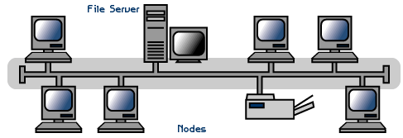
Fig.1. Linear Bus topology
Terminator
Terminator

Advantages of a Linear Bus Topology
- Easy to connect a computer or peripheral to a linear bus.
- Requires less cable length than a star topology.
- Failure of a single node does not terminate the network
- If a cable that connect the nodes with the backbone fails, the network does not fail

Disadvantages of a Linear Bus Topology
- Entire network shuts down if there is a break in the main cable (backbone).
- Terminators are required at both ends of the backbone cable.
- Difficult to identify the problem if the entire network shuts down.

2. Star Topology
A star topology is designed with each node (file server, workstations, and peripherals) connected directly to a central network hub or concentrator (See fig. 2).Data on a star network passes through the hub or concentrator before continuing to its destination. The hub or concentrator manages and controls all functions of the network. It also acts as a repeater for the data flow. This configuration is common with twisted pair cable; however, it can also be used with coaxial cable or fiber optic cable.
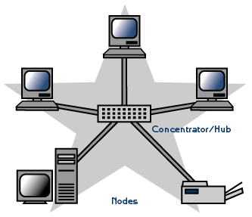
Fig. 2. Star topology

Advantages of a Star Topology
- Easy to install and wire.
- No disruptions to the network when connecting or removing devices.
- Easy to detect faults and to remove parts.
- Easily scalable, i.e., you can add a node easily
- Failure of a single computer/cable does not affect the rest of the network

Disadvantages of a Star Topology
- Requires more cable length than a linear topology.
- If the hub or concentrator fails, nodes attached are disabled.
- More expensive than linear bus topologies because of the cost of the concentrators and extra cost of the hub.
- Broadcasting creates unnecessary network traffic.
3. Ring Topology
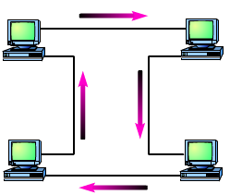
A Ring topology is the one in which all microcomputers and other communication devices are connected in a continuous loop. Electronic messages are passed around the ring in one direction, with each node serving as the repeater, until they reach the right destination. Since, all messages are flowing in only one direction; failure of a single node can compromise the entire network.

Fig.3. Ring topology

Advantages of a Ring Topology
- There is less signal attenuation because each computer in the network is used as a repeater.
- More than one computer can send data at a time.

Disadvantages of a Ring Topology
- Difficult to setup
- If any computer/cable in the ring fails, the whole network goes down.

4. Mesh Topology
- Each computer is directly connected to every other computer.
- A mesh topology can become quite complex as wiring and connections increase rapidly with the increase of computers to connect. For n computers, n(n-1)/2 cables are required.

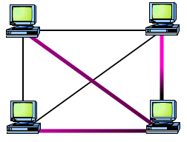
Fig.4. Mesh topology
- Today, the mesh topology is rarely used, and then only in a WAN environment and only because the mesh topology is fault tolerant. Computers or network devices can switch between these multiple, redundant connections if the need arises. On the con side, the mesh topology is expensive and quickly becomes too complex.

Considerations When Choosing a Topology:
Each topology has its advantages and drawbacks. Creating a simple network for a handful of computers in a single room is usually done most efficiently using a bus topology because it is simple and easy to install. Larger environments are usually wired in a star because moves, adds, and changes to the network are more efficient with a physical star than with any of the other topologies.
If you need high uptime or fault resistance (like 99% uptime, or less than 8 hours total downtime per year), you should seriously consider a mesh layout bearing in mind mesh topology requires taking care of n(n-1)/2 connections to maintain.
Generally speaking, balance the following considerations when choosing a physical topology for your network:
- Cost: A linear bus network may be the least expensive way to install a network; you do not have to purchase concentrators.
- Future growth (Scalability): With a star topology, expanding a network is easily done by adding another concentrator.
- Cable type: The most common cable in schools is unshielded twisted pair, which is most often used with star topologies.
- Ease of installation
- Ease of maintenance
- Cable fault tolerance
- Transmission Modes
In a network, there is always a sender and a receiver for communication to occur. Depending on the direction and simultaneity of data transmission between the sender and the receiver, we have three types of transmission, namely: Simplex, half-duplex, and full-duplex.
- Simplex: in simplex transmission mode, data is transmitted only in one direction, i.e., from source to destination. E.g., Television transmission
- Half-duplex: data can be transmitted in both direction but not simultaneously, i.e., either from sender to receiver or from the reverse at a time. E.g., Citizen Band
- Full-duplex: data can be transmitted in both directions simultaneously. E.g., telephone
- Transmission Medias
Although it is possible to use several forms of wireless networking, such as radio and infrared, most networks communicate via some sort of cable. Cable is the medium through which information usually moves from one network device to another. There are several types of cable which are commonly used with LANs. In some cases, a network will utilize only one type of cable, other networks will use a variety of cable types. The type of cable chosen for a network is related to the network's topology, protocol, and size. Understanding the characteristics of different types of cable and how they relate to other aspects of a network is necessary for the development of a successful network.
- Twisted-pair
- Coaxial
- Fiber -optic

Twisted-Pair Cable
Twisted pair cabling comes in two varieties: shielded and unshielded.

Unshielded Twisted Pair (UTP) Cable
UTP is the most popular and is generally the best option for school networks (See fig. 1).
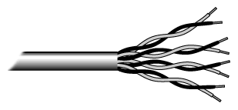
Fig.1. Unshielded twisted pair
The quality of UTP may vary from telephone-grade wire to extremely high-speed cable. The cable has four pairs of wires inside the jacket. Each pair is twisted with a different number of twists per inch to help eliminate interference from adjacent pairs and other electrical devices. The tighter the twisting, the higher the supported transmission rate and the greater the cost per foot.
When electromagnetic signals are conducted on copper wires that are in close proximity (such as inside a cable), some electromagnetic interference occurs. This interference is called crosstalk.
Twisting two wires together as a pair minimizes such interference and also provides some protection against interference from outside sources. This cable type is the most common today. It is popular for several reasons:
- It's cheaper than other types of cabling.
- It's easy to work with.
- It permits transmission rates considered impossible ten years ago.
The EIA/TIA (Electronic Industry Association/Telecommunication Industry Association) has established standards of UTP and rated five categories of wire. Category 6 is relatively new and is used for gigabit connections.

Categories of Unshielded Twisted Pair
- Category 1: Two twisted-pair (four wires). Voice grade (not rated for data communications). The oldest UTP.
- Category 2: Four twisted-pair (eight wires). Suitable for up to 4Mbps.
- Category 3: Four twisted-pair (eight wires), with three twists per foot. Acceptable for 10Mbps. A popular cable choice since the mid-80s.
- Category 4: Four twisted-pair (eight wires) and rated for 16Mbps.
- Category 5: Four twisted-pair (eight wires) and rated for 100Mbps.
- Category 6: Four twisted-pair (eight wires) and rated for 1000Mbps. Became a standard in December 1998.
Buy the best cable you can afford; most schools purchase Category 3 or Category 5. If you are designing a 10 Mbps Ethernet network and are considering the cost savings of buying Category 3 wire instead of Category 5, remember that the Category 5 cable will provide more "room to grow" as transmission technologies increase.

Unshielded Twisted Pair Connector
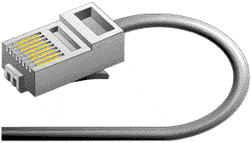
The standard connector for unshielded twisted pair cabling is an RJ-45 connector. This is a plastic connector that looks like a large telephone-style connector (See fig. 2). A slot allows the RJ-45 to be inserted only one way. RJ stands for Registered Jack, implying that the connector follows a standard borrowed from the telephone industry. This standard designates which wire goes with each pin inside the connector.
Fig. 2. RJ-45 connector

Shielded Twisted Pair (STP) Cable
Twisted-pair cable consists of multiple, individually insulated wires that are twisted together in pairs. Sometimes a metallic shield is placed around the twisted pairs. Hence, the name shielded twisted-pair (STP).
A disadvantage of UTP is that it may be susceptible to radio and electrical frequency interference. Shielded twisted pair (STP) is suitable for environments with electrical interference; however, the extra shielding can make the cables quite bulky. Shielded twisted pair is often used on networks using Token Ring topology.
- Coaxial Cable
Coaxial cabling has a single copper conductor at its center. A plastic layer provides insulation between the center conductor and a braided metal shield (See fig. 3). The metal shield helps to block any outside interference from fluorescent lights, motors, and other computers.

Fig.3. Coaxial cable
Although coaxial cabling is difficult to install, it is highly resistant to signal interference. In addition, it can support greater cable lengths between network devices than twisted pair cable.
The two types of coaxial cabling are thick coaxial and thin coaxial.
- Thin coaxial cable is also referred to as thinnet. It is 10Base2. 10Base2 refers to the specifications for thin coaxial cable carrying Ethernet signals. The 2 refers to the approximate maximum segment length being 200 meters. In actual fact the maximum segment length is 185 meters. Thin coaxial cable is popular in school networks, especially linear bus networks.
- Thick coaxial cable is also referred to as thicknet. It is 10Base5. 10Base5 refers to the specifications for thick coaxial cable carrying Ethernet signals. The 5 refers to the maximum segment length being 500 meters. Thick coaxial cable has an extra protective plastic cover that helps keep moisture away from the center conductor. This makes thick coaxial a great choice when running longer lengths in a linear bus network. One disadvantage of thick coaxial is that it does not bend easily and is difficult to install.

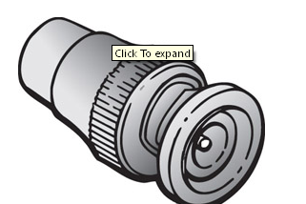
Coaxial Cable Connectors
- (BNC) connector: The most common type of connector used with ThinNet coaxial cables is the Bayone-Neill-Concelman (BNC) connector (See fig. 4). To help avoid problems with your network, always use the BNC connectors that crimp, rather than screw, onto the cable.
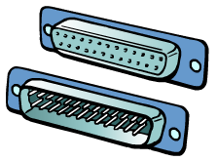
Fig. 4. BNC connector
D-type Connectors: The first type of networking connector was the D-type connector. A D-type connector is characterized by its shape. The Attachment Unit Interface (AUI) connector is a D-type connector used to connect your computer to ThickNet coaxial cable.
Fig.5. D-type connector

- Fiber Optic Cable
Fiber optic cabling consists of a center glass core surrounded by several layers of protective materials (See fig. 5). It transmits light rather than electronic signals eliminating the problem of electrical interference. This makes it ideal for certain environments that contain a large amount of electrical interference. It has also made it the standard for connecting networks between buildings, due to its immunity to the effects of moisture and lighting.
Fiber optic cable has the ability to transmit signals over much longer distances than coaxial and twisted pair. It also has the capability to carry information at vastly greater speeds. This capacity broadens communication possibilities to include services such as video conferencing and interactive services. The cost of fiber optic cabling is comparable to copper cabling; however, it is more difficult to install and modify. 10BaseF refers to the specifications for fiber optic cable carrying Ethernet signals.

Fig.5. Fiber optic cable

Fiber Optic Connector
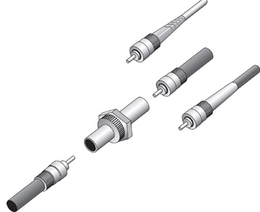
The most common connector used with fiber optic cable is an ST connector. It is barrel shaped, similar to a BNC connector. A newer connector, the SC, is becoming more popular. It has a squared face and is easier to connect in a confined space.
Fig. ST connector

Ethernet Cable Summary
Specification | Cable Type | Maximum length
10BaseT | Unshielded Twisted Pair | 100 meters
10Base2 | Thin Coaxial | 185 meters
10Base5 | Thick Coaxial | 500 meters
10BaseF | Fiber Optic | 2000 meters

- Networking Devices

- The Network Interface Card (NIC)
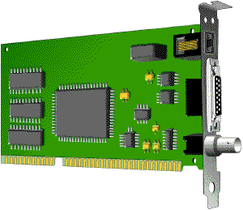
  - The network interface card (NIC) provides the physical connection between the network and the computer workstation. Most NICs are internal, with the card fitting into an expansion slot inside the computer. Some computers, such as Mac Classics, use external boxes which are attached to a serial port or a SCSI port. Laptop computers can now be purchased with a network interface card built-in or with network cards that slip into a PCMCIA slot.

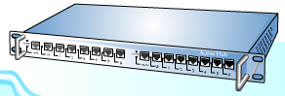
- Hub
  - A hub is the central device in a star topology. Most hubs are simple multiport repeaters. That is, they receive a signal on one port and repeat it to all other ports.

- Repeaters
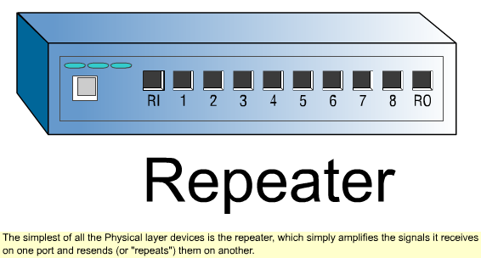
- Since a signal loses strength as it passes along a cable, it is often necessary to boost the signal with a device called a repeater. The repeater electrically amplifies the signal it receives and rebroadcasts it. Repeaters can be separate devices or they can be incorporated into a concentrator. They are used when the total length of your network cable exceeds the standards set for the type of cable being used.
- A good example of the use of repeaters would be in a local area network using a star topology with unshielded twisted-pair cabling. The length limit for unshielded twisted-pair cable is 100 meters. The most common configuration is for each workstation to be connected by twisted-pair cable to a multi-port active concentrator. The concentrator amplifies all the signals that pass through it allowing for the total length of cable on the network to exceed the 100 meter limit.
- Switch
- A concentrator is a device that provides a central connection point for cables from workstations, servers, and peripherals. In a star topology, twisted-pair wire is run from each workstation to a central switch/hub. Most switches are active, that is they electrically amplify the signal as it moves from one device to another.
- Switches no longer broadcast network packets as hubs did in the past, they memorize addressing of computers and send the information to the correct location directly. Switches are:
  - Usually configured with 8, 12, or 24 RJ-45 ports
  - Often used in a star or star-wired ring topology
  - Sold with specialized software for port management
- Bridges
    - A bridge is a device that allows you to segment a large network into two smaller, more efficient networks. If you are adding to an older wiring scheme and want the new network to be up-to-date, a bridge can connect the two. The main reason for putting a bridge in a network is to connect two segments together, or to divide a busy network into two segments.
    - A bridge monitors the information traffic on both sides of the network so that it can pass packets of information to the correct location. Most bridges can "listen" to the network and automatically figure out the address of each computer on both sides of the bridge. The bridge can inspect each message and, if necessary, broadcast it on the other side of the network.
    - The bridge manages the traffic to maintain optimum performance on both sides of the network. You might say that the bridge is like a traffic cop at a busy intersection during rush hour. It keeps information flowing on both sides of the network, but it does not allow unnecessary traffic through.

- Router
- A router translates information from one network to another; it is similar to a super-intelligent bridge. Routers select the best path to route a message, based on the destination address and origin. The router can direct traffic to prevent head-on collisions, and is smart enough to know when to direct traffic along back roads and shortcuts.
- While bridges know the addresses of all computers on each side of the network, routers know the addresses of computers, bridges, and other routers on the network. Routers can even "listen" to the entire network to determine which sections are busiest -- they can then redirect data around those sections until they clear up.
- If you have a school LAN that you want to connect to the Internet, you will need to purchase a router. In this case, the router serves as the translator between the information on your LAN and the Internet. It also determines the best route to send the data over the Internet. Routers can:
- Direct signal traffic efficiently
- Route messages between any two protocols
- Route messages between linear bus, star, and ring topologies
- Route messages across fiber optic, coaxial, and twisted-pair cabling

7. MODEM
- A modem is a device that changes digital data into an analog form for transmission over an analog medium and then back to digital again at the receiving end. The term “modem” is actually an acronym that stands for MOdulator/DEModulator.

********************************END OF CHAPTER FOUR!********************************

